***3.1. - Theoretical frame:***

***3.1.1. - Oscilloscope:*** An oscilloscope, CRO (for cathode-ray oscilloscope), or DSO (for the more modern digital storage oscilloscope), is a type of electronic test instrument that allows observation of constantly varying signal voltages, usually as a two-dimensional plot of one or more signals as a function of time. Other signals (such as sound or vibration) can be converted to voltages and displayed.

Oscilloscopes are used to observe the change of an electrical signal over time, such that voltage and time describe a shape which is continuously graphed against a calibrated scale. The observed waveform can be analyzed for such properties as amplitude, frequency, rise time, time interval, distortion and others. Modern digital instruments may calculate and display these properties directly.

Originally, calculation of these values required manually measuring the waveform against the scales built into the screen of the instrument. The oscilloscope can be adjusted so that repetitive signals can be observed as a continuous shape on the screen. A storage oscilloscope allows single events to be captured by the instrument and displayed for a relatively long time, allowing observation of events too fast to be directly perceptible.

***3.1.2. – Kirchhoff’s Laws:*** Kirchhoff’s Current Law or KCL, states that the “total current or charge entering a junction or node is exactly equal to the charge leaving the node as it has no other place to go except to leave, as no charge is lost within the node“. In other words the algebraic sum of ALL the currents entering and leaving a node must be equal to zero, I(exiting) + I(entering) = 0. This idea by Kirchhoff is commonly known as the Conservation of Charge.

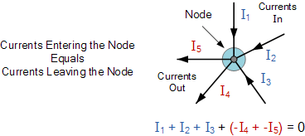

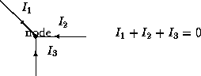

***3.1.3. – Kirchhoff’s Second Law (Voltage Law):*** Kirchhoff’s Voltage Law or KVL, states that “in any closed loop network, the total voltage around the loop is equal to the sum of all the voltage drops within the same loop” which is also equal to zero. In other words the algebraic sum of all voltages within the loop must be equal to zero. This idea by Kirchhoff is known as the Conservation of Energy.

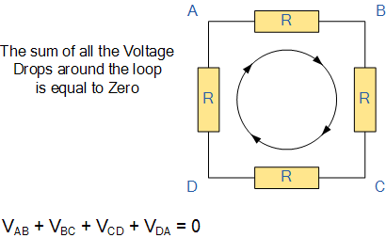

Starting at any point in the loop continue in the same direction noting the direction of all the voltage drops, either positive or negative, and returning back to the same starting point. It is important to maintain the same direction either clockwise or anti-clockwise or the final voltage sum will not be equal to zero. We can use Kirchhoff’s voltage law when analyzing series circuits.

http://www.physics.uoguelph.ca/tutorials/ohm/KVL.gif

Application of Kirchhoff's Laws to Circuits:

The current distribution in various branches of a circuit can easily be found out by applying Kirchhoff Current law at different nodes or junction points in the circuit. After that Kirchhoff Voltage law is applied, each possible loop in the circuit generates algebraic equation for every loop. By solving all these equations, one can easily find out different unknown currents, voltages and resistances in the circuits.

***Conclusion:***

As we developed the circuit in order to obtain its current using KCL I learned the importance that it has in analyzing circuits because without it we wouldn’t be able to obtain very important information about it, such as the current, how the resistors affect it, the direction it takes and how it flows over the circuit.

***Bibliography:***

<http://theory.uwinnipeg.ca/physics/curr/node8.html>

<http://www.facstaff.bucknell.edu/mastascu/elessonshtml/basic/basic5kv.html>

<http://ffden-2.phys.uaf.edu/211.fall2000.web.projects/Jeremie%20Smith/page3.htm>